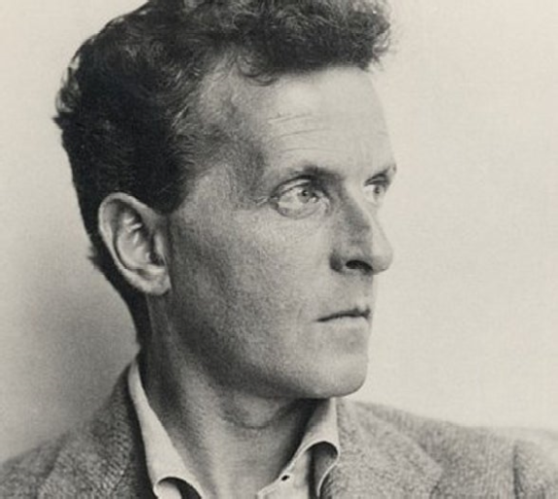
A test with Libre Office

Footnote, endnote, extended Unicode points.

AѼ㫜

Footnote
Endnote

